**Project Planning Phase**

**Project Planning (Product Backlog, Sprint Planning, Stories, Story points)**

|  |  |
| --- | --- |
| Date | 22 October 2022 |
| Team ID | PNT2022TMID14574 |
| Project Name | AI BASED DISCOURSE FOR BANKING INDUSTRY |
| Maximum Marks | 8 Marks |

**Product Backlog, Sprint Schedule, and Estimation (4 Marks)**

Use the below template to create product backlog and sprint schedule

|  |  |  |  |  |  |  |
| --- | --- | --- | --- | --- | --- | --- |
| **Sprint** | **Functional**  **Requirement (Epic)** | **User Story Number** | **User Story / Task** | **Story Points** | **Priority** | **Team Members** |
| Sprint-1 | Savings Account Related Actions | USN-1 | As a user, in the Savings Account option, I can select Types of Savings Account to get details regarding documents required for creating that savings account. | 4 | High | D.Rajasimha Reddy,B.Sai Brahma Reddy,G.Chanukya |
| Sprint-1 |  | USN-2 | As a user, I can check the Interest Rates of Savings Account | 4 | High | D.Rajasimha Reddy,B.Sai Brahma Reddy,G.Chanukya |
| Sprint-1 |  | USN-3 | As a user, I can check the Minimum Balance of Savings Account | 3 | Medium | D.Rajasimha Reddy,B.Sai Brahma Reddy,G.Chanukya |
| Sprint-1 | Current Account Related Actions | USN-4 | As a user, I can choose the Type of Company to know the information on documents to be submitted for creating current account | 5 | High | D.Rajasimha Reddy,B.Sai Brahma Reddy,G.Chanukya |
| Sprint-1 |  | USN-5 | As a user, I want to get details on procedure to close my Current Account | 4 | High | D.Rajasimha Reddy,B.Sai Brahma Reddy,G.Chanukya |
| Sprint-2 | Loan Account Related Actions | USN-6 | As a user, I can choose the Type of Loans to know the information on choosing an essential loan scheme | 3 | High | D.Rajasimha Reddy,B.Sai Brahma Reddy,G.Chanukya |
| Sprint-2 |  | USN-7 | As a user, I can check the Loan Amounts that can be offered for corresponding Loan Accounts chosen | 3 | High | D.Rajasimha Reddy,B.Sai Brahma Reddy,G.Chanukya |
| Sprint-2 |  | USN-8 | As a user, I can check the Status of Loan for my Loan Accounts | 1 | Low | D.Rajasimha Reddy,B.Sai Brahma Reddy,G.Chanukya |
| **Sprint** | **Functional**  **Requirement (Epic)** | **User Story Number** | **User Story / Task** | **Story Points** | **Priority** | **Team Members** |
| Sprint-2 | General Queries Related Actions | USN-9 | As a user, I want to get the procedure details for  Currency Conversion facility of my bank account | 2 | Medium | D.Rajasimha Reddy,B.Sai Brahma Reddy,G.Chanukya |
| Sprint-2 |  | USN-10 | As a user, I want to check my CIBIL score for my loan application and to ensure whether my loan application is approved by the bank. | 1 | Low | D.Rajasimha Reddy,B.Sai Brahma Reddy,G.Chanukya |
| Sprint-2 |  | USN-11 | As a user, I want to get the procedure details for maintaining Storage Locker facility of my bank account | 3 | High | D.Rajasimha Reddy,B.Sai Brahma Reddy,G.Chanukya |
| Sprint-2 | Net Banking Related Actions | USN-12 | As a user, I want to get the procedure details for changing the Net Banking password of my bank account | 3 | High | D.Rajasimha Reddy,B.Sai Brahma Reddy,G.Chanukya |
| Sprint-2 |  | USN-13 | As a user, I can select types of fund transfers to get details regarding different services available in net banking | 2 | Medium | D.Rajasimha Reddy,B.Sai Brahma Reddy,G.Chanukya |
| Sprint-2 |  | USN-14 | As a user, I want to get the procedure details for adding beneficiaries to my net banking account. | 2 | Medium | D.Rajasimha Reddy,B.Sai Brahma Reddy,G.Chanukya |
| Sprint-3 | Web Application | USN-15 | As a user, I want to access the chatbot in a web browser that can be accessed from almost all devices. | 20 | High | D.Rajasimha Reddy,B.Sai Brahma Reddy,G.Chanukya |
| Sprint-4 | User Interface and Web Pages | USN-16 | As a user, I want to view pages of the banking website and have access to the chatbot easily. | 20 | High | D.Rajasimha Reddy,B.Sai Brahma Reddy,G.Chanukya |

|  |  |  |  |  |  |  |
| --- | --- | --- | --- | --- | --- | --- |
| **Sprint** | **Total Story Points** | **Duration** | **Sprint Start Date** | **Sprint End Date (Planned)** | **Story Points**  **Completed (as on**  **Planned End Date)** | **Sprint Release Date (Actual)** |
| Sprint-1 | 20 | 6 Days | 24 Oct 2022 | 29 Oct 2022 | 18 | 02 Nov 2022 |
| Sprint-2 | 20 | 6 Days | 31 Oct 2022 | 05 Nov 2022 | 22 | 05 Nov 2022 |
| Sprint-3 | 20 | 6 Days | 07 Nov 2022 | 12 Nov 2022 | 20 | 12 Nov 2022 |
| Sprint-4 | 20 | 6 Days | 14 Nov 2022 | 19 Nov 2022 | 20 | 19 Nov 2022 |

**Project Tracker, Velocity & Burndown Chart: (4 Marks)**

|  |  |  |  |
| --- | --- | --- | --- |
| **Sprint** | **Total Story Points** | **Duration** | **Average Velocity** |
| Sprint-1 | 20 | 6 Days | 20/6 = 3.33 |
| Sprint-2 | 20 | 6 Days | 20/6 = 3.33 |
| Sprint-3 | 20 | 6 Days | 20/6 = 3.33 |
| Sprint-4 | 20 | 6 Days | 20/6 = 3.33 |
| **Overall** | **80** | **24 Days** | **80/24 = 3.33** |

**Velocity Chart:**

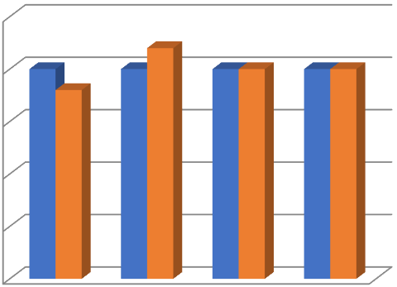

0

5

10

15

20

25

Sprint1

Sprint2

Sprint3

Sprint4

Commitment

Work Completed

**Burndown Chart:**

Sprint 1

Sprint 2

**0**

**5**

**10**

**15**

**20**

**25**

**31**

**-**

**10**

**-**

**2022**

**01**

**-**

**11**

**-**

**2022**

**02**

**-**

**11**

**-**

**2022**

**03**

**-**

**11**

**-**

**2022**

**04**

**-**

**11**

**-**

**2022**

**05**

**-**

**11**

**-**

**2022**

Burn Down Chart

**0**

**5**

**10**

**15**

**20**

**25**

**24**

**-**

**10**

**-**

**2022**

**25**

**-**

**10**

**-**

**2022**

**26**

**-**

**10**

**-**

**2022**

**27**

**-**

**10**

**-**

**2022**

**28**

**-**

**10**

**-**

**2022**

**29**

**-**

**10**

**-**

**2022**

Burn Down Chart

Sprint 3

Sprint 4

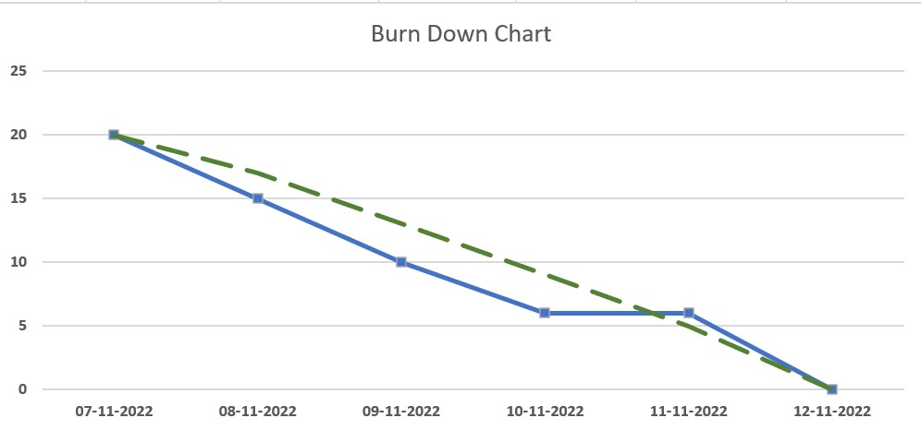

**0**

**5**

**10**

**15**

**20**

**25**

**14**

**-**

**11**

**-**

**2022**

**15**

**-**

**11**

**-**

**2022**

**16**

**-**

**11**

**-**

**2022**

**17**

**-**

**11**

**-**

**2022**

**18**

**-**

**11**

**-**

**2022**

**19**

**-**

**11**

**-**

**2022**

Burn Down Chart

**Summary of Stand- Up Calls**

|  |  |  |  |  |  |  |  |
| --- | --- | --- | --- | --- | --- | --- | --- |
| **Question** | **Person** | **SPRINT-1** | | | | |  |
| **24-10-2022** | **25-10-2022** | **26-10-2022** | **27-10-2022** | **28-10-2022** | **29-10-2022** |
| What did you do yesterday? | **Abhishek B** | - | Creation of IBM Watson Assistant Service | - | - | - | - |
| **Adithya R** | - | Creation of IBM Watson Assistant Service | Created Queries for Types of Savings Account | Created Queries for Minimum Balance of Savings Account | - | - |
| **Prathyush Krishnen J** | - | Creation of IBM Watson Assistant Service | - | - | Queries for Type of Company (Half Done) | Queries for Type of  Company and Closure of Current Account |
| **Ramkumar K** | - | Creation of IBM Watson Assistant Service | - | - | - | - |
| What will you work on today? | **Abhishek B** | Creation of IBM Watson Assistant Service | - | - | - | - | - |
| **Adithya R** | Creation of IBM Watson Assistant Service | Created Queries for Types of Savings Account | Created Queries for Minimum Balance of Savings Account | - | - | Queries to check Interest Rates of Savings Account |
| **Prathyush Krishnen J** | Creation of IBM Watson Assistant Service | - | - | Queries for Type of Company | Queries for Type of Company and Closure of Current  Account | - |
| **Ramkumar K** | Creation of IBM Watson Assistant Service | - | - | - | - | - |
| Do you have any obstacles? | **Abhishek B** | - | - | - | - | - | - |
| **Adithya R** | - | - | - | - | - | - |
| **Prathyush Krishnen J** | - | - | - | - | Time was insufficient to complete | - |
| **Ramkumar K** | - | - | - | - | - | - |

|  |  |  |  |  |  |  |  |
| --- | --- | --- | --- | --- | --- | --- | --- |
| **Question** | **Person** | **SPRINT-2** | | | | |  |
| **31-10-2022** | **1-11-2022** | **2-11-2022** | **3-11-2022** | **4-11-2022** | **5-11-2022** |
| What did you do yesterday? | **Abhishek B** | - | - | - | - | CIBIL Score | Storage Locker |
| **Adithya R** | - | Complete Minimum Balance of Savings Account | - | - | - | - |
| **Prathyush Krishnen J** | - | - | - | Currency Conversion | - | - |
| **Ramkumar K** | - | - | Type of Loan | Status of Loan | CIBIL Score | Storage Locker |
| What will you work on today? | **Abhishek B** | - | - | - | CIBIL Score | Storage Locker | - |
| **Adithya R** | Complete Minimum Balance of Savings Account | - | - | - | - | - |
| **Prathyush Krishnen J** | - | - | Currency Conversion | - | - | - |
| **Ramkumar K** | - | Type of Loan | Status of Loan | CIBIL Score | Storage Locker | Loan Amount |
| Do you have any obstacles? | **Abhishek B** | - | - | - | - | - | - |
| **Adithya R** | - | - | - | - | - | - |
| **Prathyush Krishnen J** | - | - | - | - | - | - |
| **Ramkumar K** | - | - | - | - | - | - |

|  |  |  |  |  |  |  |  |
| --- | --- | --- | --- | --- | --- | --- | --- |
| **Question** | **Person** | **SPRINT-3** | | | | |  |
| **07-11-2022** | **08-11-2022** | **09-11-2022** | **10-11-2022** | **11-11-2022** | **12-11-2022** |
| What did you do yesterday? | **Abhishek B** | - | - | - | - | - | - |
| **Adithya R** | - | - | - | - | - | - |
| **Prathyush Krishnen J** | - | Tutorial Videos on Flask | Install Flask and the Relevant Dependencies | Design a Simple Webpage to host through Flask | - | Run and check the application |
| **Ramkumar K** | - | Tutorial Videos on Flask | Install Flask and the Relevant Dependencies | Design a Simple Webpage to host through Flask | - | Run and check the application |
| What will you work on today? | **Abhishek B** | - | - | - | - | - | - |
| **Adithya R** | - | - | - | - | - | - |
| **Prathyush Krishnen J** | Tutorial Videos on Flask | Install Flask and the Relevant Dependencies | Design a Simple Webpage to host through Flask | - | Run and check the application | Take the relevant screenshots |
| **Ramkumar K** | Tutorial Videos on Flask | Install Flask and the Relevant Dependencies | Design a Simple Webpage to host through Flask | - | Run and check the application | Take the relevant screenshots |
| Do you have any obstacles? | **Abhishek B** | - | - | - | - | - | - |
| **Adithya R** | - | - | - | - | - | - |
| **Prathyush Krishnen J** | - | - | - | - | - | - |
| **Ramkumar K** | - | - | - | - | - | - |

|  |  |  |  |  |  |  |  |
| --- | --- | --- | --- | --- | --- | --- | --- |
| **Question** | **Person** | **SPRINT-4** | | | | |  |
| **14-11-2022** | **15-11-2022** | **16-11-2022** | **17-11-2022** | **18-11-2022** | **19-11-2022** |
| What did you do yesterday? | **Abhishek B** | - | Integrating the Chatbot | Integrating the Chatbot | Developing and Designing a Webpage | Developing and Designing a Webpage | Testing and Previewing the Chatbot |
| **Adithya R** | - | Integrating the Chatbot | Integrating the Chatbot | Developing and Designing a Webpage | Developing and Designing a Webpage | Testing and Previewing the Chatbot |
| **Prathyush Krishnen J** | - | - | - | - | - | - |
| **Ramkumar K** | - | - | - | - | - | - |
| What will you work on today? | **Abhishek B** | Integrating the Chatbot | Integrating the Chatbot | Developing and Designing a Webpage | Developing and Designing a Webpage | Testing and Previewing the Chatbot | Testing and Previewing the Chatbot |
| **Adithya R** | Integrating the Chatbot | Integrating the Chatbot | Developing and Designing a Webpage | Developing and Designing a Webpage | Testing and Previewing the Chatbot | Testing and Previewing the Chatbot |
| **Prathyush Krishnen J** | - | - | - | - | - | - |
| **Ramkumar K** | - | - | - | - | - | - |
| Do you have any obstacles? | **Abhishek B** | - | - | - | - | - | - |
| **Adithya R** | - | - | - | - | - | - |
| **Prathyush Krishnen J** | - | - | - | - | - | - |
| **Ramkumar K** | - | - | - | - | - | - |

# Stand-up Meeting Screenshots

## Sprint 1

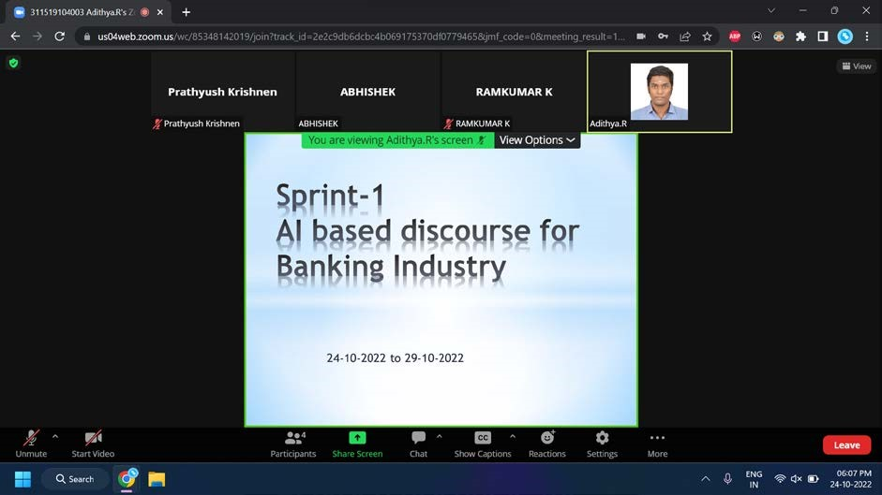

## Sprint 2

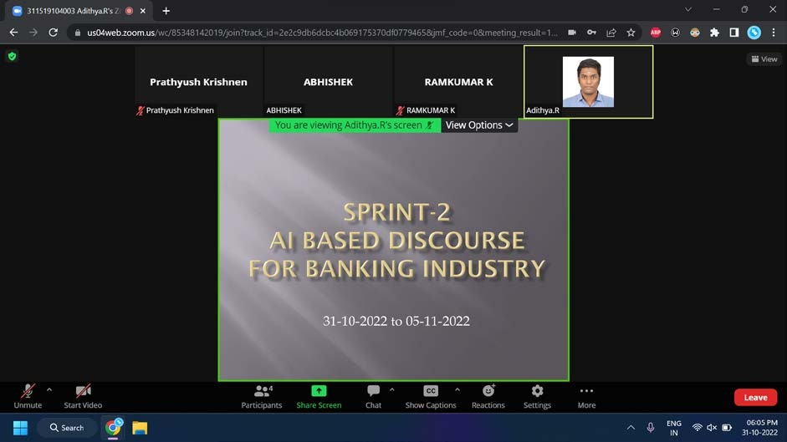

## Sprint 3

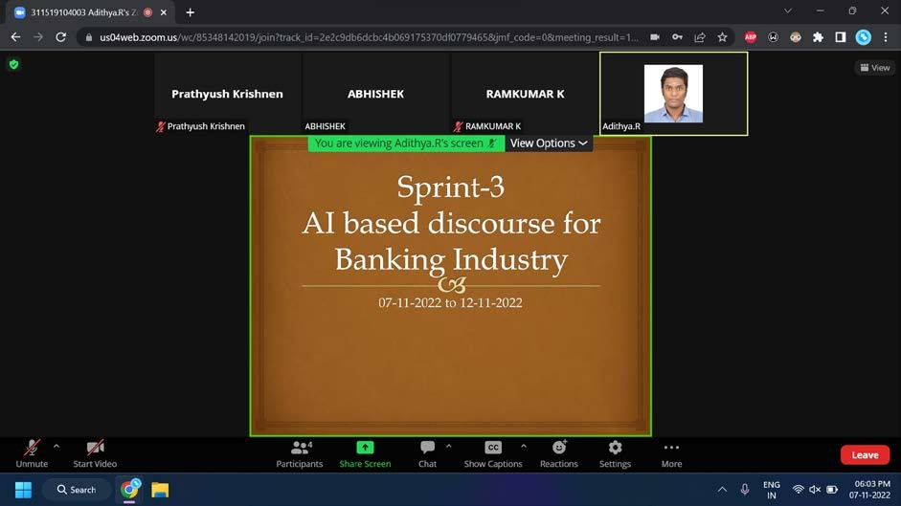

## Sprint 4

